**Final Project First Draft**

Title: Final Project Draft 1

Notice: Dr. Bryan Runck

Author: Eric Gibson

Date: October 31, 2023

**Project Repository:** *<if applicable weblink to public repository>*

**Google Drive Link:** *<if applicable with data, notebooks, etc.>*

**Time Spent:** *<report to the nearest quarter hour>*

**Abstract**

High-pointing has become a popular activity among outdoor enthusiasts looking for a tough, but satisfying objective. Many of these high points are well-marked with roads or trails to the summits, however some do not provide a defined route where a more in-depth analysis of slopes, land cover types, and stream locations are needed. Too steep of a slope is not just physically draining, but potentially dangerous. Land cover types are also important to consider, as areas of perpetual snow and ice or open water should be avoided when designing a route. Preferences also change depending on the individual, so it is also important to provide different weights to both land cover and slope. The outcome of this project are several different cost surfaces with differently weighted slopes and land cover types along with a route line drawn from a starting location to the high point which is easily accessible to the peaks chosen for the study. This draft focuses specifically on the highest point in Wyoming, Gannett Peak.

**Problem Statement**

Many high points throughout the world have suggestions for reaching the peak based on human observation alone without GIS analysis. While some provide relatively simple routes to the top, others, like Gannett Peak, the highest point in the state of Wyoming, are much more difficult to conquer. This project uses several cost surfaces created by analyzing both DEM and land use raster datasets to find a route which is best regarding slope and land use type. Various cost surfaces and routes were created to effectively relate to different individuals and their preferences. Within this first draft, only the cost surfaces have been created.

*Table 1. Deliverables for the Final Project*

|  |  |  |  |  |  |  |
| --- | --- | --- | --- | --- | --- | --- |
| **#** | **Requirement** | **Defined As** | **(Spatial) Data** | **Attribute Data** | **Dataset** | **Preparation** |
| 1 | Cost surfaces | Various cost surfaces weighted based on slope and land use types for individual preferences. | Raster dataset (GeoTIFF) | Route quality | [Land Use](https://s3-us-west-2.amazonaws.com/mrlc/nlcd_2021_land_cover_l48_20230630.zip)  [DEMs](https://apps.nationalmap.gov/downloader/) | Reclassify, uniquely weight, and calculate the raster datasets. |
| 2 | Polyline dictating best route | Lines created using the different cost surfaces of unique preferences. | Vector polyline data of optimal route | Length, elevation increase | [Land Use](https://s3-us-west-2.amazonaws.com/mrlc/nlcd_2021_land_cover_l48_20230630.zip)  [DEMs](https://apps.nationalmap.gov/downloader/) | After creating cost surfaces, analyze the optimal route for reaching the peak. |
| 3 | Start and end points of routes | Points depicting an easy-access starting point and the high point. | Vector point data of the starting and end point of each route | Name, elevation | Starting point created via Arcpy  End point found via Google Places API | Gather coordinate data from Google Places API and Google Earth to create the points in ArcGIS Pro. |

**Input Data**

The first dataset is a collection of digital elevation models (DEM) with a one-meter spatial resolution stitched together to create a larger DEM of the northwestern Wind River Range. This data was published by the United States Geological Survey (USGS) through their 3D Elevation Program. The elevations are recorded in meters and provide accurate slope information due to the small spatial resolution. The second dataset is a 30-meter spatial resolution raster depicting land use types within Wyoming including forest cover, barren land, urban landscapes, and water features. This dataset provides useful information for areas to avoid when high-pointing. The last datasets needed are the starting and end points of each route. These datasets simply include coordinate information for a starting point at an easy-access location, like a trailhead or point on a defined trail, and coordinate information gathered using the Google Places API with a query searching for the high point name.

*Table 2. Datasets needed for performing the project.*

|  |  |  |  |
| --- | --- | --- | --- |
| **#** | **Title** | **Purpose in Analysis** | **Link to Source** |
| 1 | Wyoming DEM | Create a raster dataset defining slope and stream locations to form cost surfaces. | [Wyoming DEM](https://apps.nationalmap.gov/downloader/) |
| 2 | Wyoming Land Use Raster | Weight certain land use types based on how well they can be traversed to form cost surfaces. | [Wyoming Land Use](https://s3-us-west-2.amazonaws.com/mrlc/nlcd_2021_land_cover_l48_20230630.zip) |
| 3 | Starting point | Provide a starting point for the optimal route to the high point. | Created point using Arcpy |
| 4 | High point | Provide an end point for the optimal route beginning at the starting point. | Coordinate data gathered via Google Places API |

**Methods**

*Figure 1. Data flow diagram depicting incomplete workflow for final project.*

This workflow describes the process for creating the final cost surfaces as well as the incomplete flow to provide the polyline data presenting the optimal routes. Many of these processes are loosely defined, as there are always potential setbacks, corrections, and work-arounds to provide the most accurate and effective data. For example, within this first draft open water, snow and ice, wetlands, vegetation, and other land cover types were weighted as 5, 4, 3, 2, and 1 respectively, however this is subject to change based on various research and potential survey information. Weighting land cover and slope will likely be done utilizing the 0.1 to 0.9 model as shown above to provide the most possible cost surface outcomes.

**Results**

*Show the results in figures and maps. Describe how they address the problem statement.*

*Follow best practice for map design, coloring, etc.*

Any blues dictate areas most adequate to traverse, while reds depict areas least adequate to traverse. Originally, the areas of open water did not weight properly since the slope is equal to zero at these locations. This problem was solved by reclassifying all locations on the cost surface equal to zero to the maximum number on the cost surface. If other locations outside of areas of open water have a slope of zero, this may be a flawed solution, so better fixes are being tested for the final project.

*Figure 2. Initial draft cost surface depicting slope and land cover weighted equally.*

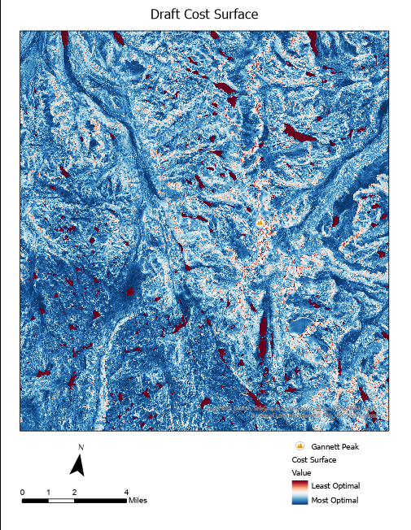

**Results Verification**

This initial cost surface was shows a continuous change in areas to traverse if slope and land cover were weighted about equally with all slope angles were weighted based on their angle value and land cover types were weighted as mentioned within the **Methods** section. Although this initial cost surface works well for individuals who weight land cover and slope relatively equivalently, eight other cost surfaces will be created to find optimal high point routes where land cover and slope are most and least important when compared to each other. This will provide a wide range of solutions for outdoor enthusiasts with various wants and needs for hiking.

The weighting of the land cover types themselves is also clear, illustrating open water and snow and ice as more greatly weighted, while forested and wetland environments are less weighted. Open water is mostly impenetrable for hikers, so it is depicted with a dark red symbology indicating to avoid these areas, while snow and ice are to be largely avoided and still predominantly present a red symbology. The slope raster dataset was not reclassified into classes defined by a range of angles, so slope is shown with a more continuous depiction within the figures above.

It is also important to note the workflow to create the polylines presenting the optimal high point routes is undetermined, so this will be implemented later on in the project’s life cycle.

**Discussion and Conclusion**

*What did you learn? How does it relate to the main problem?*

This first draft provided a useful look into my project and established and confirmed how I would like to conquer it moving forward. First of all, some issues I came across regard some of the weighting and raster calculations. I did not foresee the issue of the slope of open water multiplied by the land cover raster value. Since open water, like a lake, has a slope of zero, it cannot be weighted in a typical way, so any of these areas should either be removed from the study completely or manually given a large weight if possible. This draft also provided me with some further glimpses into how I want to weight specifically land cover data. While this draft used some research and personal understandings of certain land cover types which are difficult to traverse, the best way to gather this information may be to create a survey asking outdoor enthusiasts what their most and least desirable land cover types to traverse are. This could provide accurate and professionally-backed data instead of a largely arbitrary weighting system regarding land cover.

**References**

“Trail Grades (and Outslope).” *Trailism*, trailism.com/trail-grades/#:~:text=The%20USFS%20Accessibility%20Guidelines%20put%20outslope%20%28or%20cross,target%20grade%20is%205-18%25%2C%20max%2035%25%2C%20outslope%205-20%25%21. Accessed 31 Oct. 2023.

Seidl, Lauren. “How Difficult Is Your Route? Hiking Classes Defined | Sierra Blog.” *Sierra*, 24 June 2020, www.sierra.com/blog/hiking/hiking-classes-defined/. Accessed 31 Oct. 2023.

**Self-score**

|  |  |  |  |
| --- | --- | --- | --- |
| **Category** | **Description** | **Points Possible** | **Score** |
| **Structural Elements** | All elements of a lab report are included **(2 points each)**:  Title, Notice: Dr. Bryan Runck, Author, Project Repository, Date, Abstract, Problem Statement, Input Data w/ tables, Methods w/ Data, Flow Diagrams, Results, Results Verification, Discussion and Conclusion, References in common format, Self-score | 28 |  |
| **Clarity of Content** | Each element above is executed at a professional level so that someone can understand the goal, data, methods, results, and their validity and implications in a 5 minute reading at a cursory-level, and in a 30 minute meeting at a deep level **(12 points)**. There is a clear connection from data to results to discussion and conclusion **(12 points)**. | 24 |  |
| **Reproducibility** | Results are completely reproducible by someone with basic GIS training. There is no ambiguity in data flow or rationale for data operations. Every step is documented and justified. | 28 |  |
| **Verification** | Results are correct in that they have been verified in comparison to some standard. The standard is clearly stated **(10 points)**, the method of comparison is clearly stated **(5 points)**, and the result of verification is clearly stated **(5 points)**. | 20 |  |
|  |  | 100 |  |